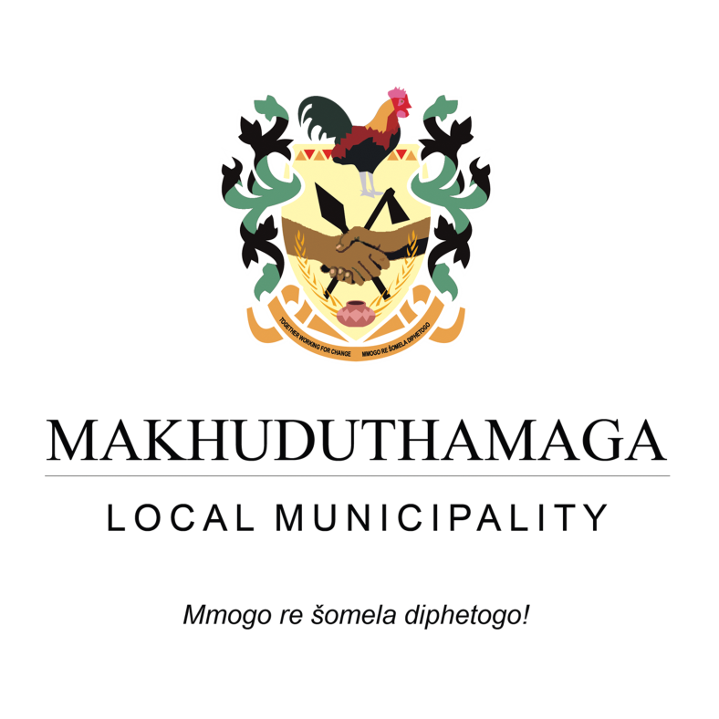

2019/20 IDP/Budget Process Plan
Approved by council on the 30th July 2018

1. Introduction
An IDP serves as a single, inclusive and strategic plan for the development of the municipality which spans for a period of five years and is reviewed annually. It is a collaborative planning process aimed at guiding municipalities to eradicate service delivery backlogs while encouraging socio-economic development. This process seeks to preserve and conserve the environment and address spatial disparities for the development of, and delivering on, agreed priorities which are translated into projects with clearly defined outputs and targets over a five year planning cycle.
The Municipal IDP can also be viewed as a five year service delivery commitment to the community by those elected and entrusted with ensuring that the IDP becomes reality. It is integrated in such a way that it should be a reflection of government’s wider plans such as the District Municipality’s plans and the relevant Provincial and National Governments’ plans. The IDP should also be informed by the community it serves and must be backed up by the necessary funding. This implies that an annual budget must be approved by the Municipal Council which shall ensure that financial resources are made available in order to ensure that the priorities and the projects identified are implemented in order to achieve the predetermined five year development objectives.
Municipalities are also expected to establish a Performance Management System in terms of Section 38 of the Municipal Systems Act (Act no.32 of 2000). The Performance Management System of the municipality will assist in ascertaining as to what extent the municipality is thriving towards the attainment of its development objectives as indicated in its Integrated Development Plan. This will also allow the municipality to identify shortcomings and thereby devising strategies to address these shortcomings. In a nutshell, the Performance Management System seeks to monitor and assess the implementation of the municipality’s Integrated Development Plan and its budget alike at particular intervals.
It can be deducted therefore that the processes of Integrated Development Planning, Budgeting and Performance Management are inseparable but mutually inclusive.
2. Legislative Framework
Section 28 of the Municipal Systems Act (2000) provides that “each municipal council, within a prescribed period after the start of its elected term, must adopt a process set out in writing to guide the planning, drafting, adoption and review of its integrated development plan.” Section 29(1) of the Municipal Systems Act (2000) further stipulates that the process followed by a municipality to draft its Integrated Development Plan, including its consideration and adoption of the draft plan, must:
- be in accordance with a predetermined programme specifying timeframes for the different steps;
(b) through appropriate mechanisms, processes and procedures established in terms of Chapter 4, allow for –
i. the local community to be consulted on its development needs and priorities
ii. the local community to participate in the drafting of the Integrated Development Plan; and iii. Organs of state, including traditional authorities, and other role players to be identified and consulted on the drafting of the Integrated Development Plan. (c) Provide for the identification of all plans and planning requirements binding on the municipality in terms of national and provincial legislation; and (d) be consistent with any other matters that may be prescribed by regulation.
- Another piece of legislation that governs the preparation of the process for the planning, drafting, adoption and review of a municipality’s Integrated Development Plan is Section 21 (1) paragraph (b) of the Municipal Finance Management Act (Act no. 56 of 2003) which provides that the Mayor of a Municipality must, at least 10 months before the start of the Budget year, table in the Municipal Council a time schedule outlining key deadlines for –
- (i) the preparation, tabling and approval of the annual budget; (ii) the annual review of:
(a) The Integrated Development Plan in terms of Section 34 of the Municipal Systems Act; and (b) the Budget related policies.
iii) The tabling and adoption of any amendments to the Integrated Development Plan and the budget related policies (iv) Any consultative processes forming part of the process referred to in subparagraphs (i), (ii) and (iii).
- This particular report (IDP, Budget and Performance Management System Process Plan 2019-20) therefore gives effect to the above stipulated legislative provisions in order to guide the planning, drafting, adoption and review of Makhuduthamaga IDP 2019/20. This is also to ensure that the IDP is not only aligned to the annual budget and performance management system but also responsive to the developmental needs of the community served by Makhuduthamaga Council.
- Furthermore, this Process Plan was prepared in line with the Sekhukhune District Municipality’s Framework Plan adopted in terms of Section 27 of the Municipal Systems Act (2000). This was to ensure that proper consultation, coordination and alignment of the IDP process for the Sekhukhune District Municipality and its four local municipalities can be maintained.
.

Below is the Draft Schedule for the review of IDP/Budget for the 2019/20 Financial Year
Month | Action | Target date
PREPARATORY PHASE
July 2018 | - Review of previous year’s IDP/Budget process  - Exco provides political guidance over the budget process and priorities that must inform preparations of the budget  - IDP/Budget Steering Committee meeting  - 4th Quarter Performance Lekgotla (2017-18)  - Submit IDP/Budget Process Plan for 2019/20 to Council | July 2018
August 2018 | - Submit Annual Financial Statements for 2017/18 to AG  - Submit 2017/18 cumulative Performance Report to AG and Council Structures  - Operational Risk Assessment for 2018/2019  - Ward to Ward based data collection  - Collate information from ward based data | August 2018
Month | Activity | Target date
ANALYSIS PHASE
September 2018 | - Council determines strategic objectives for service delivery through IDP review processes and the development of the next 3 year budget (including review of sector department plan)  - Consult with provincial and national sector departments on sector specific programmes for alignment (libraries, schools, clinics, water, electricity, roads, sanitation, etc.)  - Finalise ward based data compilation  - Update Council Structures on updated data | September 2018
Month | Activity | Target date
STRATEGIES PHASE
October 2018 | - Quarterly (1st ) review of the 2018/19 budget, related policies, amendments (if necessary),any related process  - Begin preliminary preparations on proposed budget for 2019/20 financial year  - 1st Quarter Performance Lekgotla (2018/19) | October 2018
Month | Activity | Target date
PROJECTS PHASE
November 2018 | - Confirm IDP Projects with District and Sector departments  - Review and effect changes on the initial IDP draft | November 2018
Month | Activity | Target date
INTEGRATION PHASE
December 2018 | - Table Draft 2017/18 Annual Report to Council  - Review budget performance and prepare for adjustment  - Consolidated Analysis Phase in Place  - IDP/Budget Steering Committee meeting  - IDP Representative Forum | December 2018
January 2019 | - Table Draft 2017/18 Annual Report to Council  - Submit Draft Annual Report to AG,PT and CoGHSTA  - Publish Draft Annual Report in the Municipal jurisdiction (website etc.)  - Prepare Oversight Report for 2017/18 financial year  - Mid-Year Performance Lekgotla  - Strategic Planning Session (Review of IDP/Budget, related policies) | January 2019
Month | Activity | Target date
February 2019 | - Table Budget Adjustment (if necessary)  - Submission of Draft IDP/Budget for 2019/20 to Management  - Submission of Draft IDP/Budget and other plans to Portfolio committees  - Submission of Draft IDP/Budget to EXCO | February 2019
March 2019 | - Council considers the 2019/20 Draft IDP/Budget  - Publish the 2019/20 IDP/Budget for public comments  - Adoption Oversight Report for 2017/18 | March 2019
 | APPROVAL PHASE
April 2019 | - Submit 2018/19 Draft IDP/Budget to the National Treasury, Provincial Treasury , CoGHSTA and SDM in both printed and electronic formats  - Consultation with National and Provincial Treasuries, community participation and stakeholder consultation  - Submission of Draft IDP/Budget for 2018/19 to Council structures with incorporated comments from the consultative process  - Strategic Risk Assessment for 2018/2019  - 3rd Quarter Performance Lekgotla (2018/19) | April 2019
May 2019 | - Submission of Final Draft of IDP/ Budget for 2019/20 to the Council for approval  - Prepare SDBIP for 2019/20  - Develop Performance Agreements (Performance Plans) of MM and Senior Managers for 2019/20 Performance year  - Operational Risk assessment for 2019/2020 | May 2019
June 2019 | - Submission of approved IDP/Budget to MEC for CoGHSTA / National and Provincial Treasury and to SDM  - Submission of the SDBIP to the Mayor  - Submission of the 2019/20 Performance Agreement to the Mayor  - Notice and summary of approved budget in Gazette and Local Newspaper | June 2019

